Approaches to Access Control: RBAC vs. ABAC

In this topic, I would like to acquaint readers with a relatively new approach to access control called the Attribute-based access control . Relationship will occur on a comparison example with the popular today Role-based access control .
When a company is made up of one person, the inner secrets in it. Only employee access to any action and any information.
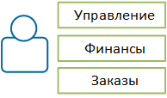
If the company is successful and the volume of work grows, there comes a moment when one person no longer cope. And then the company hired new employees.
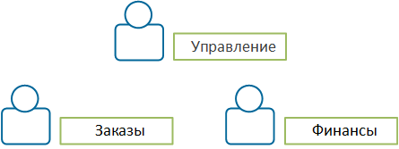
But when the number of employees in the company is increasing, there are other problems, such as:
Control
Finance
Order

Control

FinanceOrder

- each employee should perform only their own business problems and not have access to other people;
- each employee should see only associated with its business objectives of information;
- each task must be responsible for its implementation officer.
If you do not solve these problems, the company may incur financial losses due to:
- ineffective implementation of foreign problems due to incompetence;
- intentional or unintentional errors in other people's problems;
- disclosure of information to unauthorized persons.
To solve these problems, and properly restrict access, you need to understand which of your employees wants to perform an action (authentication), and if he can do it (authorization).
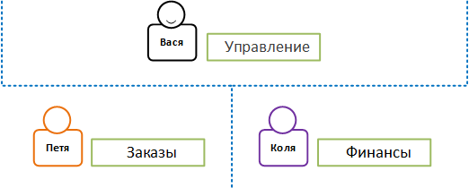
The most difficult problem is authentication. There are several approaches to solving it, but the most widely used today gained control based on roles (role-based access control, RBAC ).
Control

FinanceOrder

Role-based access control (RBAC)
The approach is to create roles, echoing the business role in the company, and assigning them to users. Based on these tests the user roles perform a particular action.
If business rules are one-dimensional and all the action can be broken down by role (accountant, manager, administrator, and so on. P.), This approach will be sufficient. Then one business rule corresponds to one role.
Business rules:
- Only hell-1inisggtraggtech can manage the company
-Only an accountant may engage in financial activities
- Only a manager can manage orders
Roles:
-Administrator
-Accountant
- Manager

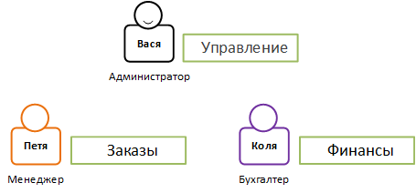
But the business rules will inevitably become more complex and multidimensional. This leads to the fact that the one attribute (role) for the expression of business rules is not enough and begins to add other attributes (city, country, branch, day of the week, the owner, the limit, and so on. N.).
To cope with this complexity, it is necessary to create additional roles, equal to the number of different combinations of attributes.
Control

FinanceOrder

Business - rules

-The manager can manage only those orders that are created, in his branch

-An accountant can manage financial affairs only in his branch

-The administrator can manage only his branch.

Roles

- Branch Manager A
- Branch Manager b
- Branch Manager "B"
-...
- Accounting of branch "A"
- Accountant branch "b"
- Accountant branch "B"
-...
- Administrator branch "A"
- Administrator branch "b"
- Administrator branch "B"

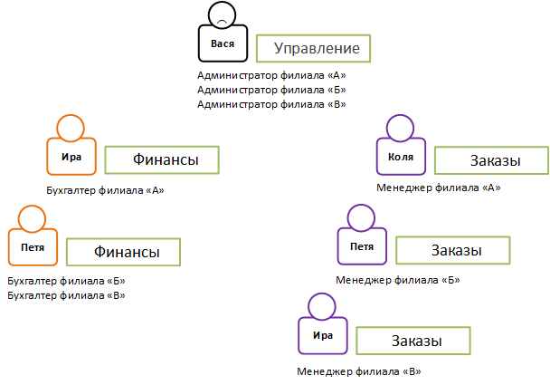
After each addition of a new attribute value will have to add a new role. That is, if there will be a branch of "G" it is necessary to add new roles, such as "Administrator of the branch of" G "," Manager of the branch of "G", "Accountant of the branch" G ", and so on. N., And then assign all the required staff new role. All this generates a lot of routine manual work.
In addition, there are other problems:
Control
- Administrator branch "A"
- Administrator branch "b"
- Administrator branch "B"

FinanceOrder
- Accounting of branch "A" - Branch Manager A

FinanceOrder
- Accountant branch "b"
- Accountant branch "B" - Branch Manager b

Order
- Branch Manager "B"
- one business rule is "smeared" among the many roles and becomes non-obvious, which complicates the understanding of the rules and their support;
- It begins the explosive growth in the number of roles, which greatly complicates management.
A business rules that use attributes whose values are not known in advance, and are evaluated in the course of work, generally can not be expressed by means of a role model.

Business -Rules

-The manager can confirm the order only if this order not created by him

-An accountant may prepare financial statements only. in weekdays

-The administrator can issue a premium that does not exceed 2096 from employee salary

There are also business rules that restrict access not to act, and to the data. These business rules and can not be expressed by means of a role model.
Business -Rules

- Pate manager to look at those orders; price quotable ‘ 1.00 rubles;

About Btter Mate and Casting From Themes incense F Deshmshtr pcs pc staff pc pc '
pcs M @ hashish

To implement support for these business rules, will have to use other tools that only increases the cost and complexity of implementation and maintenance of access control systems. It turns out that as soon as the business rules are multidimensional and require data control, a role model not only does not solve the current problems of access control, but also creates new ones.

Attribute-based access control (ABAC)
To cope with the intractable problems in the framework of RBAC, a different approach, which is based on the attributes has been created.
The main difference of this approach is that each situation is evaluated not from the standpoint of the user's role and action that he wants to do, but in terms of attributes that apply to them.
Business rule, in fact, is a set of conditions in which the various attributes must satisfy the requirements imposed on them.
You can clearly distinguish several categories of attributes.

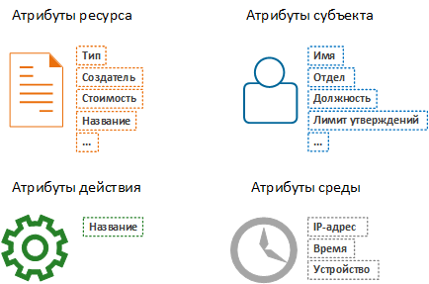
To perform authentication values of all attributes are taken at the time of inspection rights and are compared with the expected values. Fulfillment of all conditions provides access to the resource.
Simple rules described by simple conditions.
Resource Attribute Subject Attributes

Action attributes Environment attributes
Business -Rules
- Only a manager can manage orders.
Consist of and 3 conditions:
about (Yo'ggyyg'yotch;
o Object.Type = "Order"

Multidimensional rules in this model does not become more complicated.
Business rule:
-The manager can manage only those orders that are created. in his branch

It consists of the following conditions:
- Subentance = "Manager"
- Object. Type = "Order"
- about Subenagtts60sht = Object. Branch

When you add new values to attributes in a business rule condition will not change. That is, if there will be a branch of "G", in terms of business rules do not have to change anything. All that is required - it is necessary to add employees to "branch" attribute - "Branch" D ".
Thus, ABAC avoids the problems that appear in the RBAC:
- business rule is not "smeared" in the system, making it the understanding and support rather simple;
- there is no explosive growth in the number of conditions that make them easier to support.
But most importantly, ABAC can solve problems that can not be solved with the help of the RBAC, since this approach, there are no restrictions on the complexity of the business rules. Business rules of any complexity, including the use of previously unknown attributes, do not create new problems and are easy to maintain.
Business rule

- A senior purchasing manager can confirm orders. for purchase only if he is not the creator of the order the order is in his branch, the order value is more than 100 000 rubles. and does not exceed the limit approval of orders for the day

It consists of the following conditions:

- Action. Title = "Confirmation"
- Subentance == "Senior Manager"
- Subject. Division = "Procurement Division"
- Subject.Limitt of Validations <Subject. Approved on Day
- Subject! = Resource. Creator
- Subject. Branch = Resource. Branch
- Resource. Type = "Purchase Order"
- Resource. Cost of order> "100 000"

Representation of business rules as a set of conditions is useful for data filtering. Part of the conditions can be calculated prior to accessing resources, and the remaining conditions are the filter for data selection.
Business rule:
- A senior manager can only watch purchase orders, whose price is more than 100 000 rubles.

It consists of the following condition:
- with. act. Title = "View"
- and SubjectDown = "Senior Manager"
- about ct.Type = "Purchase orders"
- o ObjectPrice ›100 000

Filter:
- Object> 100,000

The first three conditions can be verified before access to the data. And the last condition can be used as a predicate to retrieve only the data allowed.

Comparison ABAC and RBAC

 | RBAC | ABAC
Description close to business terms | - | +
Without too much manual labor | - | +
Simple rules support | + | +
Support for complex rules | + | +
Support for rules with dynamic parameters | - | +
Data filtering | - | +
As can be seen from the comparison, RBAC is suitable only for simple business rules. With the increasing complexity of the rules of the feasibility of using RBAC is reduced due to the rising cost of supporting access control systems, and starting from a certain level of complexity of the rules, this approach does not give the result.
ABAC, in turn, limits the complexity of the business rules. Thanks to a cleaner business and compact expression, this approach makes it possible not to increase the cost of supporting the implementation of more complex rules, but also makes it possible to provide access control, not only to act, but also to the data.

